|  |
| --- |
|  |
| **Team TBM** |
| **Sky Rat** |
| **Game Design Document**  Version #4  All work Copyright © 2021 by Team TBM Games.  All rights reserved. |
| Catt Symonds (101209214) |
| Dhimant Vyas (101199558) |
| Cameron Akey (101166181) |
| Tran Thien Phu (101160213) |
| Blair White (100328532) |
| Luka Ivicevic (101131244) |

|  |
| --- |
| February 07th 2021 |

**Table of Contents**

**(Highlighted content is updated for the Release)**

1. **Game Overview**
2. **Game Play Mechanics**
3. **Game Dynamics**
4. **Game Aesthetics**
5. **Camera**
6. **Control**
7. **Saving and Loading**
8. **Interface Sketch**
9. **Menu and Screen Descriptions**
10. **Game world**
11. **Levels**
12. **Game Progression**
13. **Characters**
14. **Enemies**
15. **Items**
16. **Abilities**
17. **Script**
18. **Scoring**
19. **Cheat Codes**
20. **Sound Index**
21. **Story Index**
22. **Art/Multimedia Index**
23. **Design Notes**
24. **Future Features**

**Version History**

**GitHub Link**: <https://github.com/Blair-White/MobileFinal_Platformer>

* Working for First Playable.
* Initial Commit [Jan20] Commit 1.
* Added Scripts for Game Controllers [Jan23] Commit 4.
* Added Sample Map [Jan27] Commit 5.
* Added GDD [Jan27] Commit 6.
* Added Movement, Swipe controls, Sliding Left/Right [Feb3] Commit 10.
* Added Sound Assets [Feb4] Commit 12.
* Imported the final Assets. [Feb4] Commit 13.
* Created Level [Feb5] Commit 14.
* Added Camera Movement, Turning Controls, and upgraded Level. [Feb6] Commit 16.
* Added Pause UI [Feb7] Commit 17.
* Pause Menu UI fix [Feb7] Commit 19.
* Moving Platform Script Refactoring [Feb7] Commit 23.
* Added Options Scene [Feb7] Commit 29.
* Working for Second Playable
* Animations Added [Feb11] Commit 31.
* UI fixes and Health bar fixes [Feb15] Commit 33.
* Sound Added [Feb15] Commit 35.
* Level Adjustments [Feb15] Commit 36.
* Patrolling Enemy Implementation [Feb16] Commit 38.
* Hierarchy cleanup [Feb16] Commit 41.
* Update Gameplay/Inventory and added Win Scene. [Feb16] Commit 42.
* Working for Third Playable
* Pickups Added [Feb20] Commit 45.
* Logo Update/Menu Screen Update/Option Screen Update [Feb 21] Commit 47-51
* Audio Slider Fix/Level Fixes/Win Scene/Audio Asset/Death Plane/Music Add [Feb 21] Commit 52-60
* Player-Enemy Animations [Feb 23] Commit 61.
* Sound fixes/ Enemy Collision [Mar 11] Commit 65.
* Light Adjustments/Added chasing Enemy/Dynamic Sounds/Inverted Controls [Mar 12] Commit 66-68
* Working for Alpha
* Working for Beta
* Working on Final Submission.

1. **Game Overview**

*You are a pigeon trying to escape from a hawk. It is an “endless” runner game*. Instead of literally being endless, the game level will be around a large, looped track, giving the feel of endlessness without the pain of procedural generation. Speed will increase as time goes on.

1. **Game Play Mechanics**

*3D endless runner like Temple Run or Subway Surfers where player will run trying to avoid obstacles and collecting as many points as they can.*

*UPDATE*

The player begins the game running. There will be 6 checkpoints in the level. Checkpoints will function in a standard manner: once a checkpoint has been passed, if the player dies the game can start from the last checkpoint. An inventory will include collected coins and powerups. There will also be scoring dependent on how far through the level the player has gone. There will be 2 platform categories: normal and self-destructing. Self-destructing platforms will be destroyed 1 second after the player has touched them. Each of these categories includes platforms that move up and down, left, and right, and rotating platforms. After every lap, the players speed increases. If the player eats a mushroom, health decreases by 50%. After every lap, pickups will be randomly regenerated around the lap.

1. **Game Dynamics**

*The winning strategy is to play a lot until one learns to stay calm while playing, much like in games such as Flappy Bird.*

1. **Game Aesthetics**

*Our audio aesthetic is jolly pigeon country & western. Our visual aesthetic is low-poly voxel art.*

1. **Camera**

*Third Person point of view while looking at the player’s back.*

1. **Controls**

*Player can swipe left/right to change the direction and swipe up to jump.*

*update : no ducking for now maybe we can add that later.*

1. **Saving and Loading**

As it is an endless runner there will not be any checkpoints to save player stats. We will be adding checkpoints for saving game because of the requirements. when the player dies, they can save their score if it is a high score.

1. 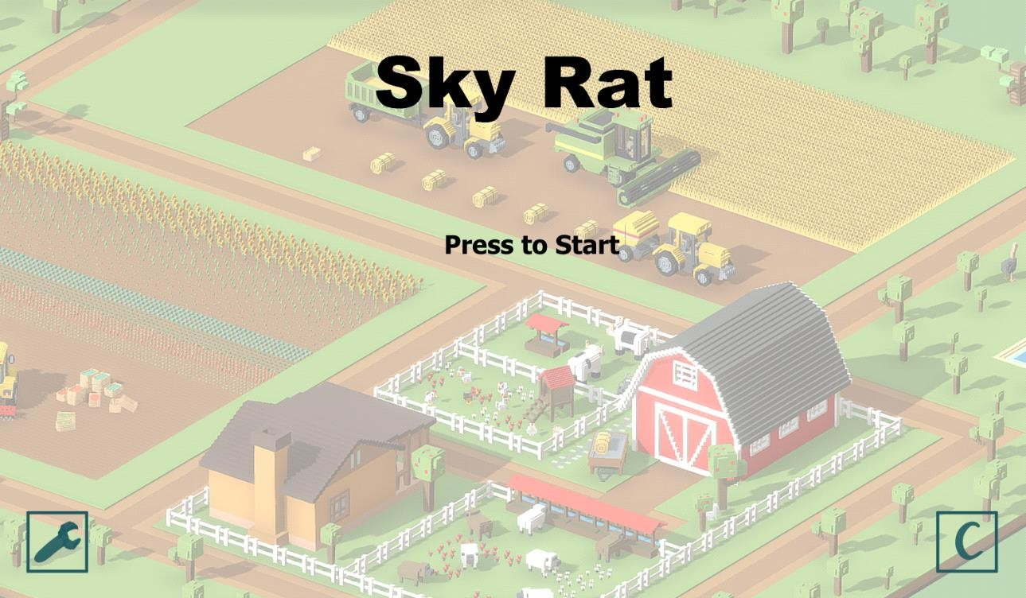**Interface Sketch**
2. **Menu and Screen Descriptions**

The Main Menu (Picture 1) is a simple layout where the player taps anywhere on the screen to begin playing the game. This is to help with miss clicks that can often occur using mobile controls. The Options button (bottom left) and the Credits button (bottom right) are small buttons, as it is often less likely for a player to want to visit either. The Level screens have minimal UI blocking the player's vision of upcoming obstacles, with the pause button and timer in the top left corner. The Level Complete screen is a relaxing blue to help deal with the frustration that can often come from infinite runners.

*UPDATE*

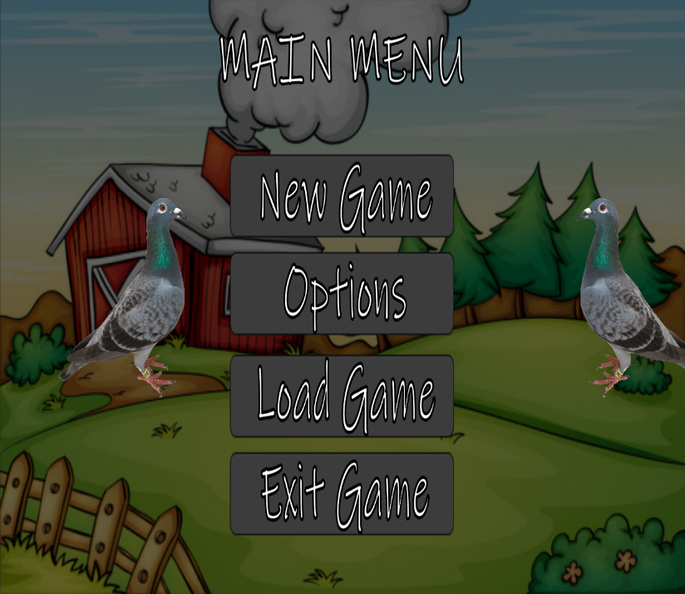**Logo Scene**  **Main Menu**

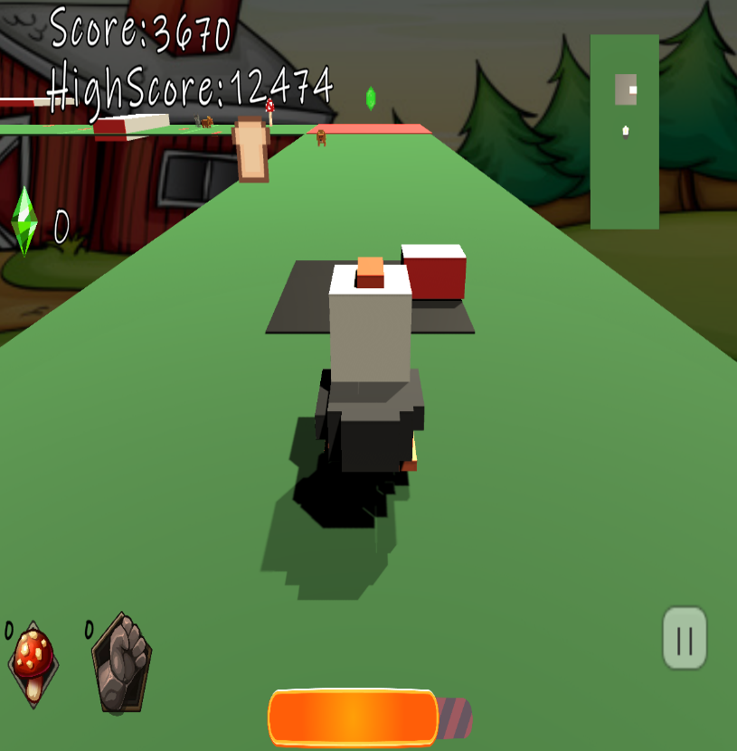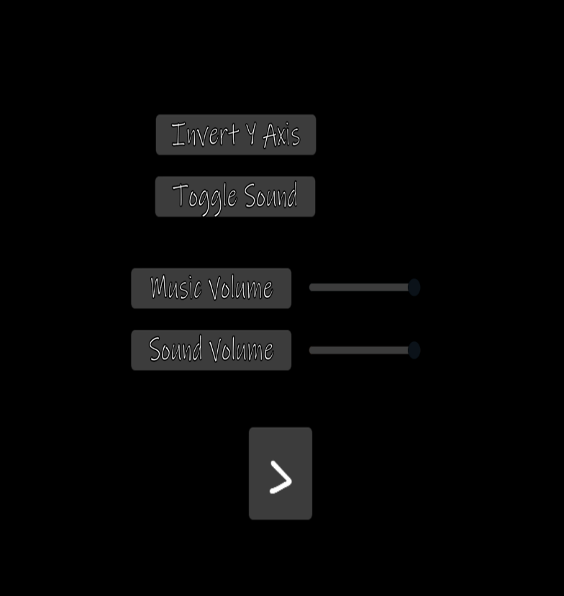**Options from Main Menu**  **Game Scene // Inventory System in bottom Left**

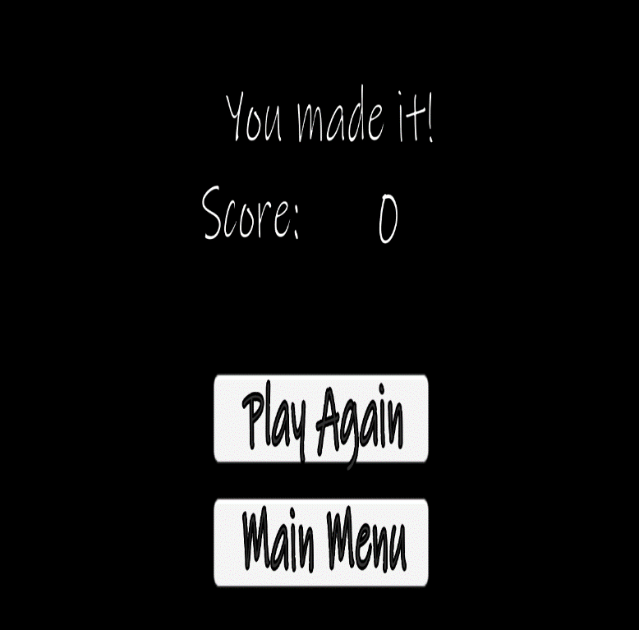**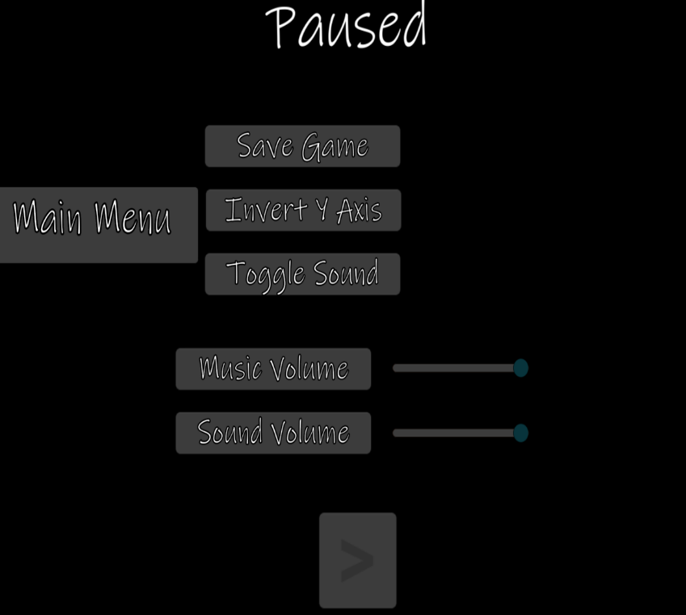Win Scene Options from Game Scene**

1. **Game World**

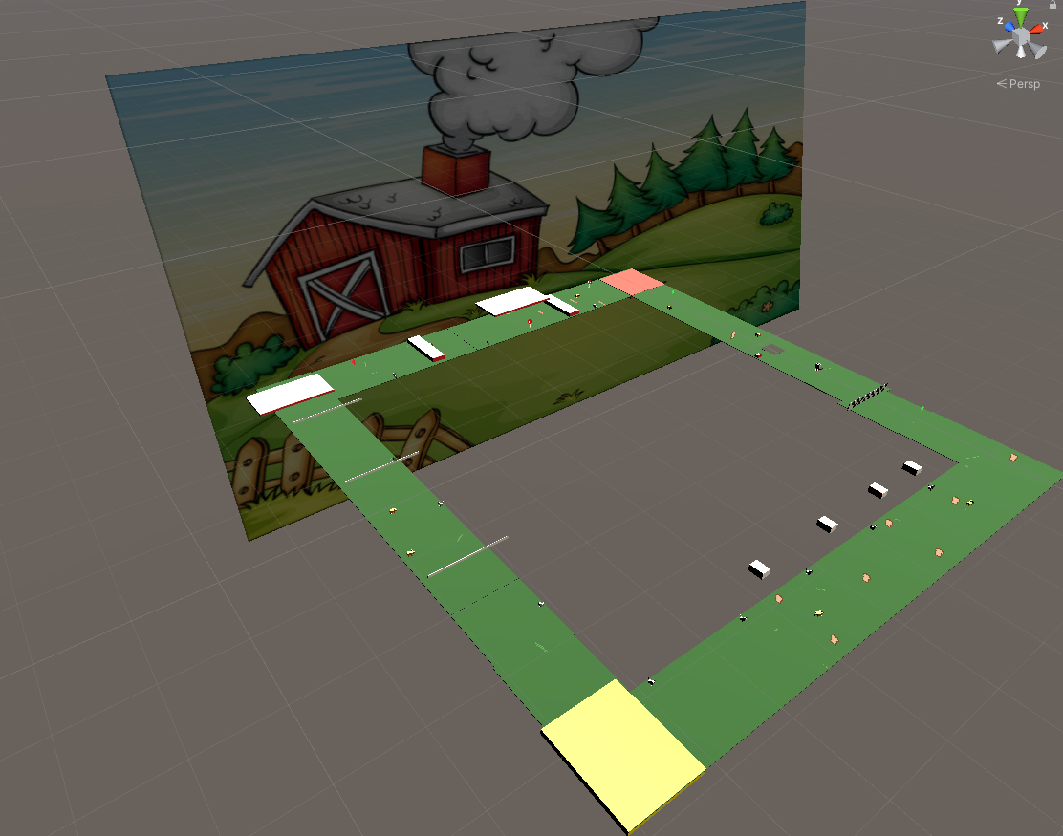*The game will take place on a farm environment. Here are some mood-setting inspiration images:*

[*https://www.turbosquid.com/3d-models/3d-model-voxel-farming-1292081*](https://www.turbosquid.com/3d-models/3d-model-voxel-farming-1292081)

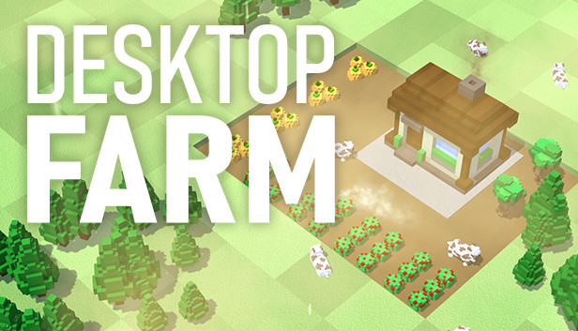

[*https://store.steampowered.com/tags/vn/Voxel/*](https://store.steampowered.com/tags/vn/Voxel/)

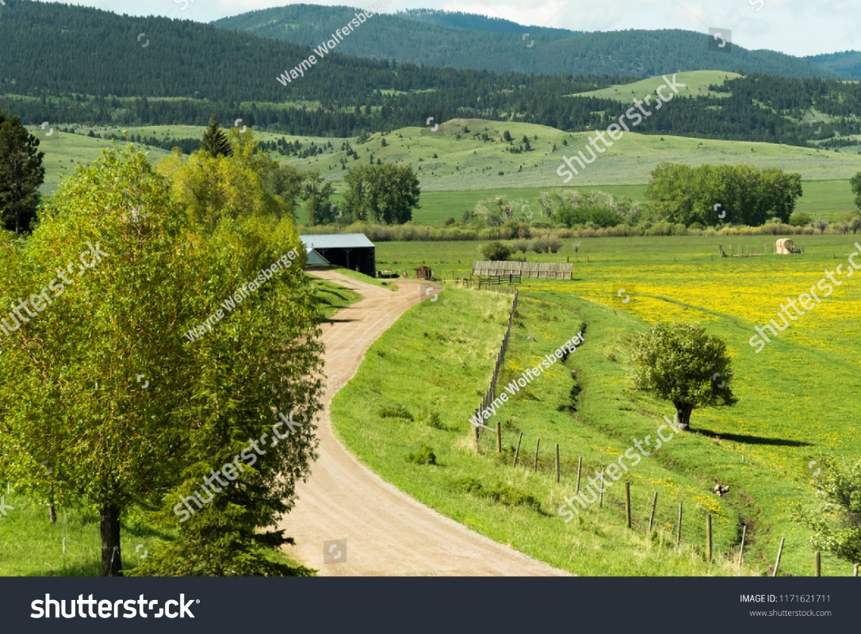

[*https://www.shutterstock.com/image-photo/scene-small-country-farm-western-montana-1171621711*](https://www.shutterstock.com/image-photo/scene-small-country-farm-western-montana-1171621711)



[*https://www.etsy.com/sg-en/listing/615628556/country-farm-limited-edition-art-print*](https://www.etsy.com/sg-en/listing/615628556/country-farm-limited-edition-art-print)

1. **Levels**

*Only one level as of now called* ***Farm.***

*UPDATE*

Two Platforms:  
1. Static Platform 2. Platform which will get destroyed after player jumping on it.

Hazards: 1. Speeds the player up 2. Mushroom if eaten will damage player.

Pickups:  
1. Coins 2. Power up slows the player down 3. Health increase

1. **Game Progression**

*Game speed will increase as the game progresses which will make it harder for them to survive. Points will also go up, allowing for the player to get high scores for a dopamine hit.*

1. **Characters**

*Player avatar is a pigeon. Pigeon will be animated with 3D Movement for running and jumping. As none of us are concept artists, I have included a picture of a pigeon.*

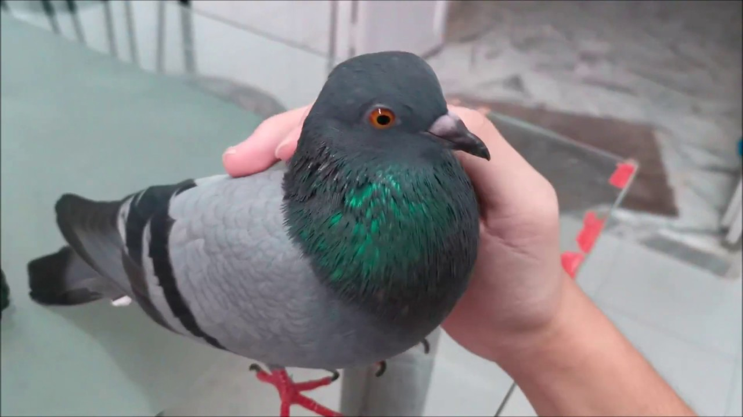

1. **Enemies**

*There will be some NPC as an obstacle which the player will need to avoid in-game. Determination of enemy type to be made upon acquisition of appropriate assets!*

*Update: New Enemy Type that follows Player.*

1. **Items**

*There will be obstacles in the level from which player has to jump or duck to pass and continue progressing. There will be hazardous pickups which the player should avoid poison that can damage the player or make the game go faster.*

*Update: Breads and Mushrooms Items as Pickups.*

1. **Abilities**

*Run left/right, jump.*

1. **Script**

*There will be no need for voice lines as the player avatar is a pigeon.*

1. **Scoring**

*As the player runs, the score will increase. There will also be pickup items that can increase the score.*

*UPDATE*

Each frame adds 0.05 points to the player’s score.

1. **Cheat Codes**

*God-mod available for the dev. purposes. (Unlimited Life)*

1. **Sound Index**

Pigeon noises.

Wind noises.

Original sound fx (and possibly music as a nice-to-have).

Update:

Harmony (Fade)

Shy Kids Lofty Album

1. **Story Index**

*Pigeon Bob was just surfing around in the farm when a hawk tries to attack. Now he must run to save his life!*

1. **Art / Multimedia Index**

|  |  |  |  |  |
| --- | --- | --- | --- | --- |
| **Asset** | **Use for** | **Format** | **Source (Creator)** | **Acquired From** |
|  | Main Character | Fbx | <https://www.cgtrader.com/workingfortheweekend> | <https://www.cgtrader.com/> |
|  | Coin | Fbx | <https://poxelgames.itch.io/> | <https://itch.io/> |
|  | Power up: Slow down | Fbx | <https://poxelgames.itch.io/> | <https://itch.io/> |
|  | Power up: Immunity | Fbx | <https://poxelgames.itch.io/> | <https://itch.io/> |
|  | Trap: Speed up | Fbx | <https://poxelgames.itch.io/> | <https://itch.io/> |
|  | Trap: Damage health | Fbx | <https://poxelgames.itch.io/> | <https://itch.io/> |
|  | Trap: Push player to other planes | Fbx | <https://poxelgames.itch.io/> | <https://itch.io/> |
|  | UI Asset | Png | <https://www.creativegameassets.com/> | <https://itch.io/> |
|  | Background Asset | Fbx | <https://www.suriyun.com/> | <https://assetstore.unity.com/> |

1. **Design Notes**

*Game starts -> Option for (Play, Instruction, Exit Game) ->*

*Play Game 🡺 Pause/Play Menu 🡺 (Main menu, Resume, Exit)*

*Instruction 🡺 Display Game play Instructions.*

*Exit 🡺 Exit the Game.*

1. **Future Features**

*Pickups for Increasing/Decreasing Health.*

*Pickups for slowing down the speed of the game.*